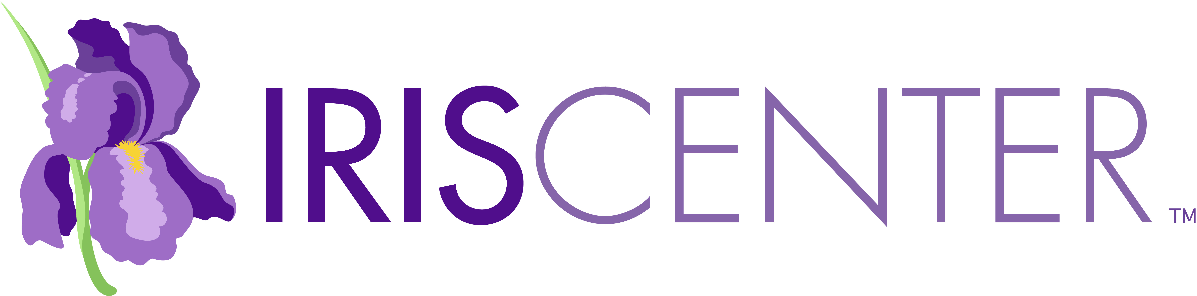
Coursework Planning Form: Faculty
Syllabus Planning Form
Directions: After exploring Modules, Case Studies, Activities, Information Briefs, Video Vignettes, and Interviews, use this form to compile your notes for a specific course(s) you teach, noting on this fillable form how you will use these IRIS resources.
Course:
Week/Session/  Topic | IRIS Resources  (STAR Legacy Module, Case Study, Activity, Information Brief, Video Vignette, Interview) | How Used
Week/Session/  Topic | IRIS Resources  (STAR Legacy Module, Case Study, Activity, Information Brief, Video Vignette, Interview) | How Used

